https://www.theforeman.org/manuals/2.4/quickstart_guide.html
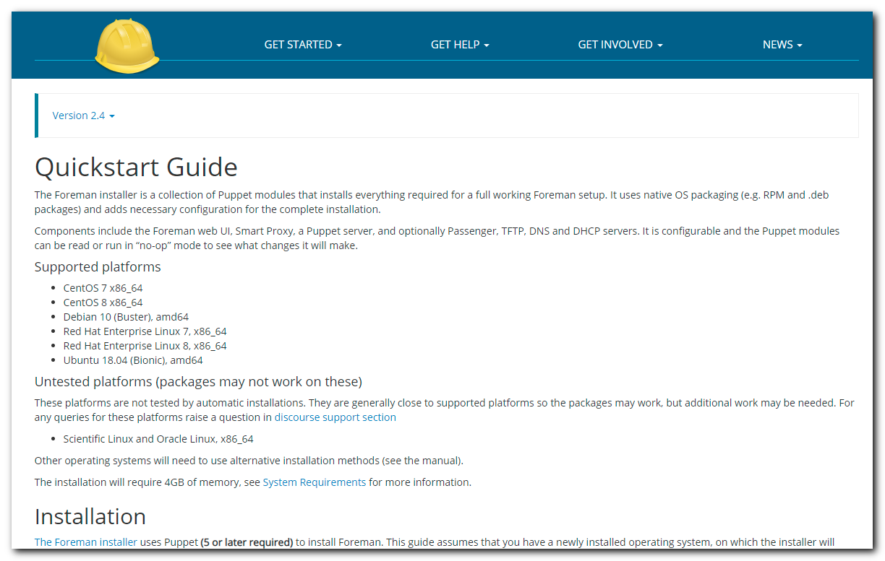
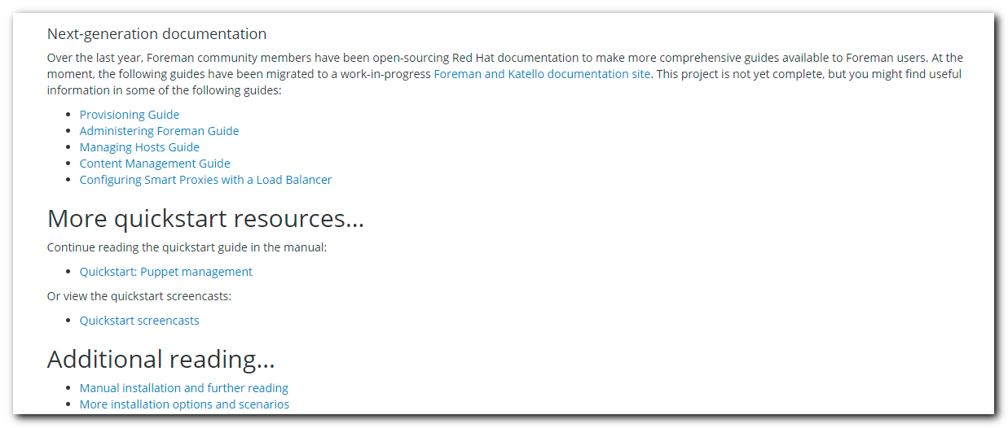

https://docs.theforeman.org/
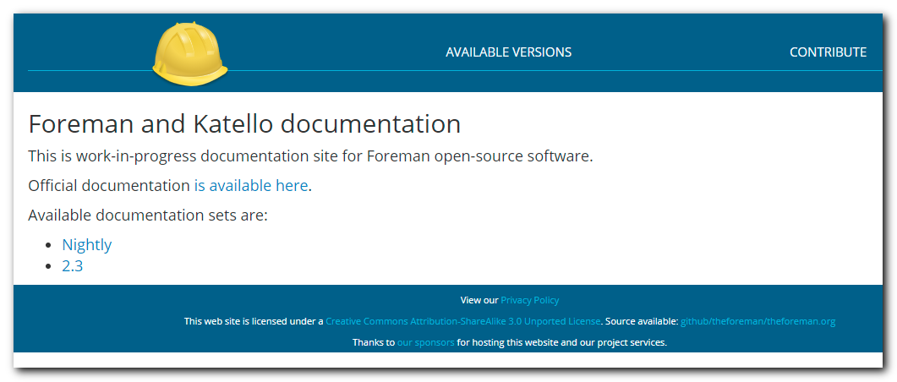

https://docs.theforeman.org/nightly.html
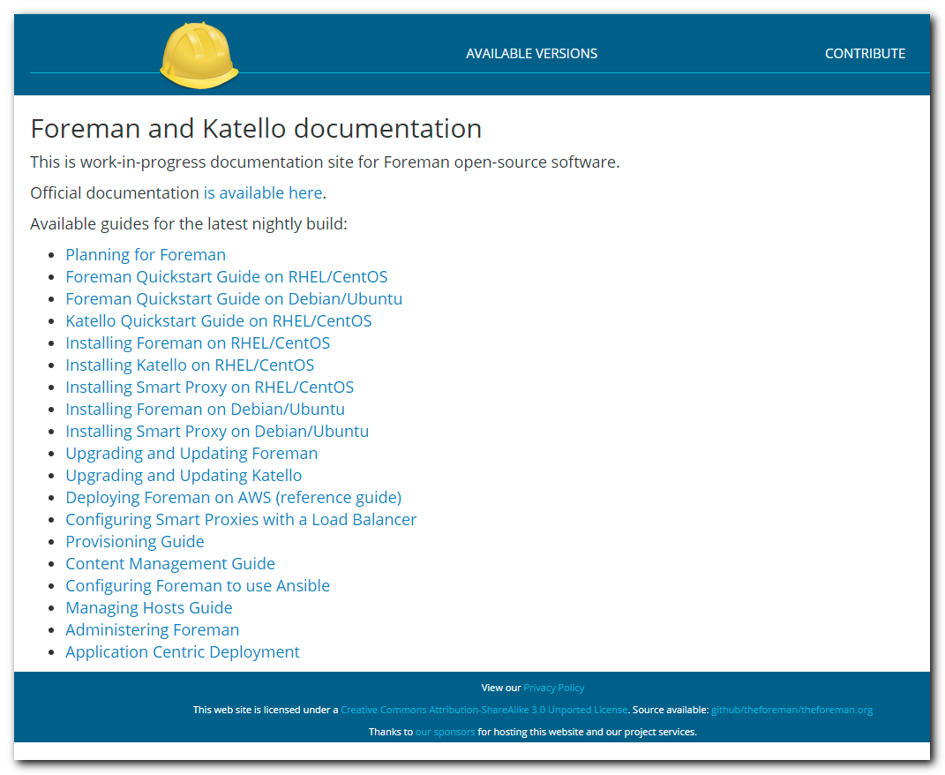

https://theforeman.org/manuals/nightly/index.html
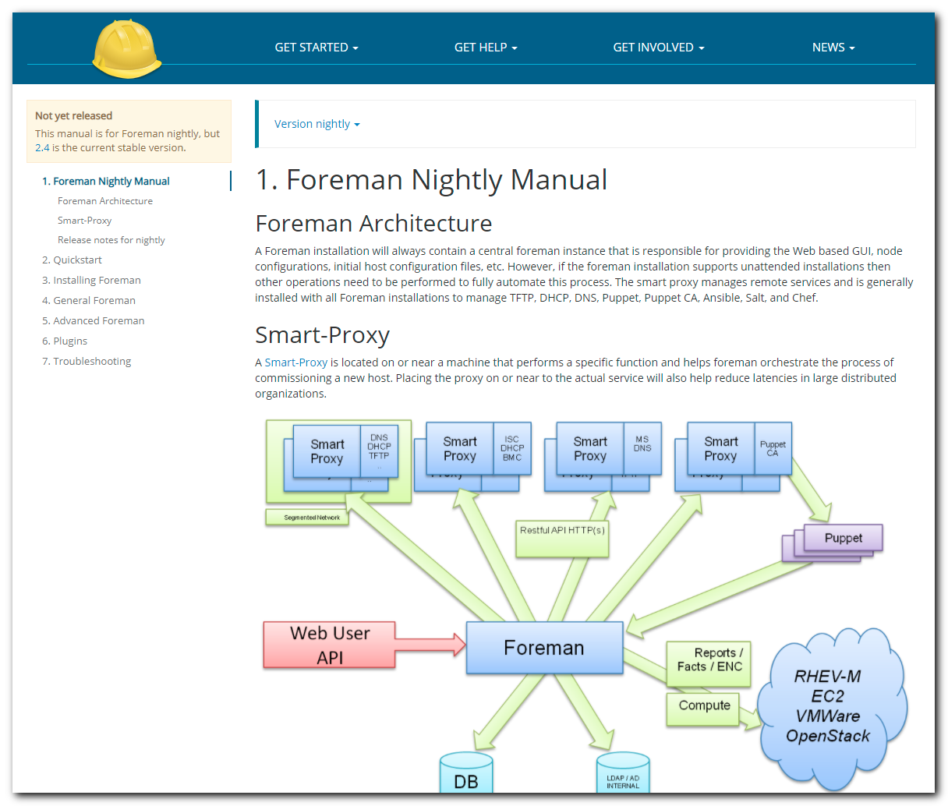

https://www.theforeman.org/media.html#screencasts
